

**Name Nadeem ullah**

**Sap id 56031**

**Semester CS3-2**

**Question 1**

#include <iostream> using namespace std;

void Menu();

int Addition(int a, int b); int Subtraction(int a, int b); int Multiplication(int a, int b); int Division(int a, int b);

void Menu() {

int choice, a, b;

cout << "Select an operation:" << endl; cout << "1. Addition" << endl; cout << "2. Subtraction" << endl; cout << "3. Multiplication" << endl; cout << "4. Division" << endl; cout << "Enter your choice: "; cin >> choice;

cout << "Enter two numbers: ";

cin >> a >> b;

switch (choice) { case 1:

cout << "Result: " << Addition(a, b) << endl;

break; case 2:

cout << "Result: " << Subtraction(a, b) << endl;

break; case 3:

cout << "Result: " << Multiplication(a, b) << endl;

break; case 4:

cout << "Result: " << Division(a, b) << endl;

break; default:

cout << "Invalid choice!" << endl;

}

}

int Addition(int a, int b) { return a + b;

}

int Subtraction(int a, int b) { return a - b;

}

int Multiplication(int a, int b) { return a * b;

}

int Division(int a, int b) {

if (b != 0)

return a / b;

else {

cout << "Error: Division by zero!" << endl;

return 0;

}

}

int main() {

Menu();

return 0;

}

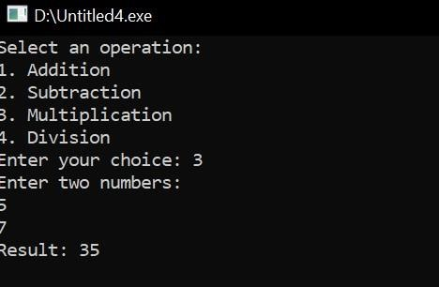

**Question 2**

#include <iostream> using namespace std;

void swap(int* x, int* y) {

int temp = *x;

*x = *y;

*y = temp;

}

int main() {

int a, b;

cout << "Enter value of a: ";

cin >> a; cout << "Enter value of b: "; cin >> b;

cout << "Before swapping: a = " << a << ", b = " << b << endl; swap(&a, &b);

cout << "After swapping: a = " << a << ", b = " << b << endl;

return 0;

}

